### Min/Max

Under “Tools > Field Settings > Min/Max” (see Figure 11‑10) the instrument boundaries can be set. For example the “Engine 1 Oil Pressure” instrument can be set as follows:

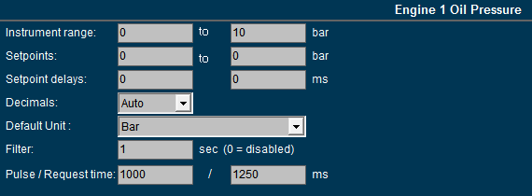

Figure 11‑10: Min/Max settings

#### Instrument range

The instrument range field is used to define the measuring range (scale) of the instrument.   
For example: the indicator below is scaled from 0 to 30 bar.

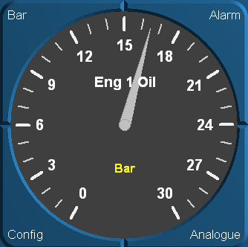

Figure 11‑11: Engine 1 oil pressure indicator (0 - 30 bar)

*:*

*In order to detect and identify a deviating function, make sure that all instrument (in a column or row) pointers are aligned to the same position (default mode).  
Check the default values of each instrument and set the instrument range accordingly.*

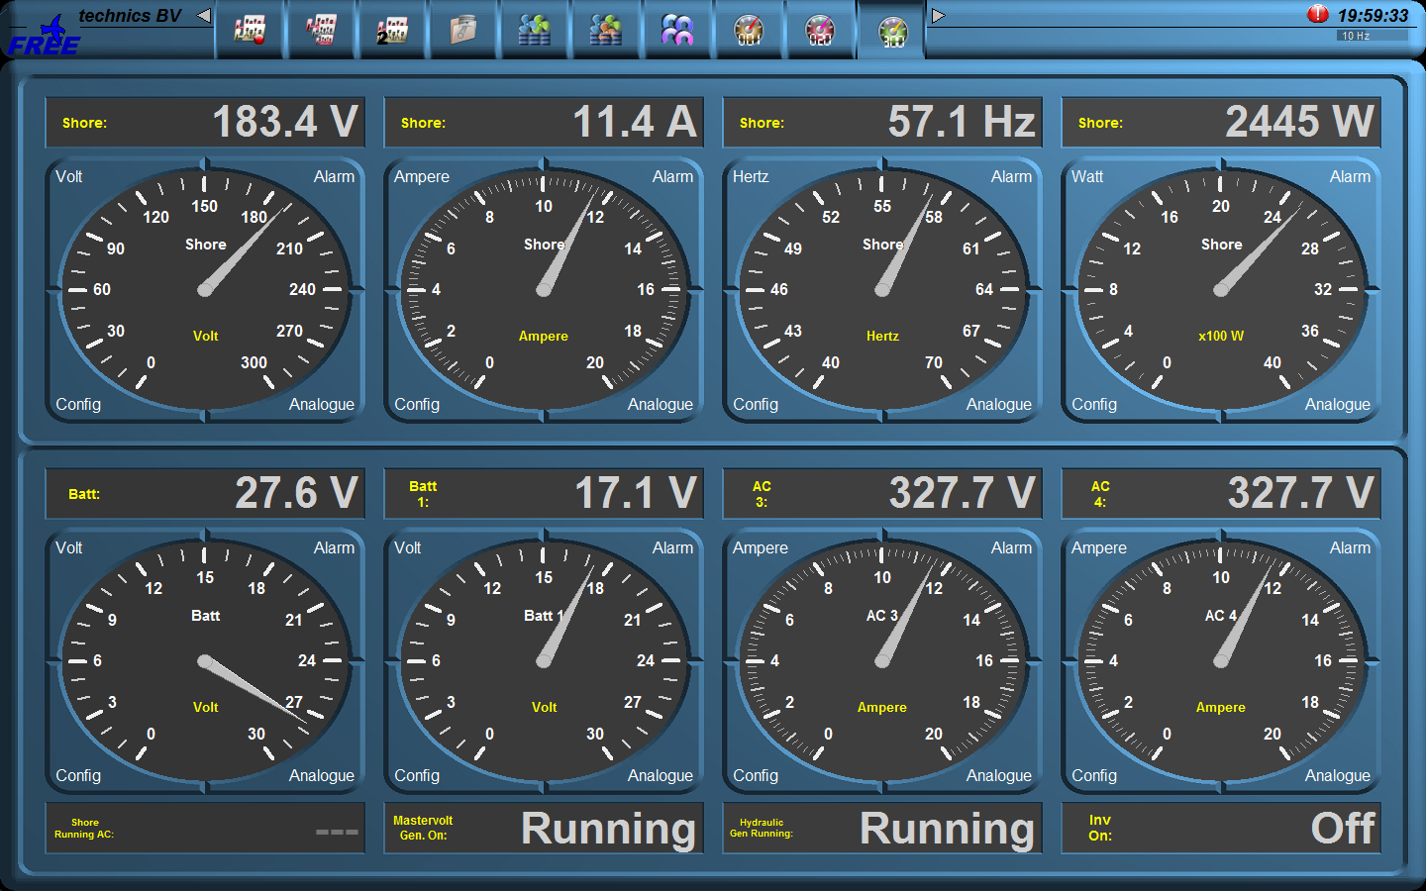

Figure 11‑12: Instrument pointers

By aligning the instrument pointers to the same position (see Figure 11‑12) it will be easier to detect a deviating function.

#### Setpoints

If the sensor values and their working ranges are known, you can set a zone marking. It puts a grid over the desired values on the instrument, to verify if the readings are correct.

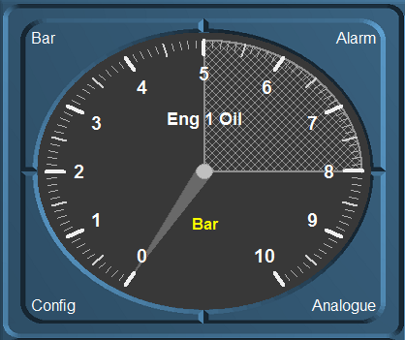

Figure 11‑13: Zone marking

: For now this is only working in regular instruments. It will be implemented later for mimic instruments.

#### Setpoint delay

Whit the delay you can set a time in milliseconds before an alarm will be triggered. This prevents recurring alarms if the sensor is working on the edge of the setpoint

#### Decimals

To make sure that in a mimic all the decimals in a value are of the same length, you can choose the number of decimals here. This will make it easier to get the same decimals for different values as FT NavVision© will calculate its own decimals. Standard is “Auto”.

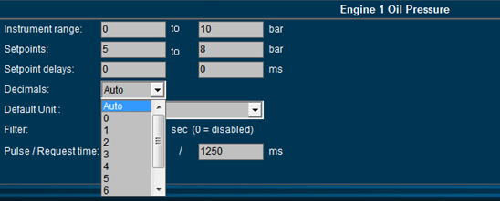

Figure 11‑14: Decimals

#### Default unit

At startup each instrument will show the unity in which it will display the data. Depending on the sensor type select the desired unity (see Figure 11‑15).

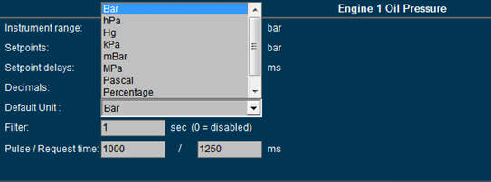

Figure 11‑15: Default unit

*: in a mimic you can choose a secondary value to show in the mimic itself. See chapter about mimics*.

#### Filter

If an instrument reading seems to be a little erratic, you can select a higher number (see Figure 11‑15) to dampen the movement of the instrument pointer.

#### Pulse/Request time

The pulse time is the time a pulse will last after pressing the button in milliseconds. If you need a longer pulse (i.e. for starting or stopping a generator) you can change it here.

The request time is how long a request stays active. For example: some valves will take up to 30 seconds to open or close. If the time is set to 1250 ms and the valve didn’t get a feedback that it was opened or closed, it will stop or give an alarm. If you increase the amount of time here, FT NavVision© will wait for that longer time to give an alarm.

This also goes for requests that are send over Modbus etc. sometimes you need to let it wait for a longer time.